A WALK BESIDE THE WILLOW RIVER · WEEKEND EDITION NO. 01

Along
the River
A little wandering.
A little time to yourself.
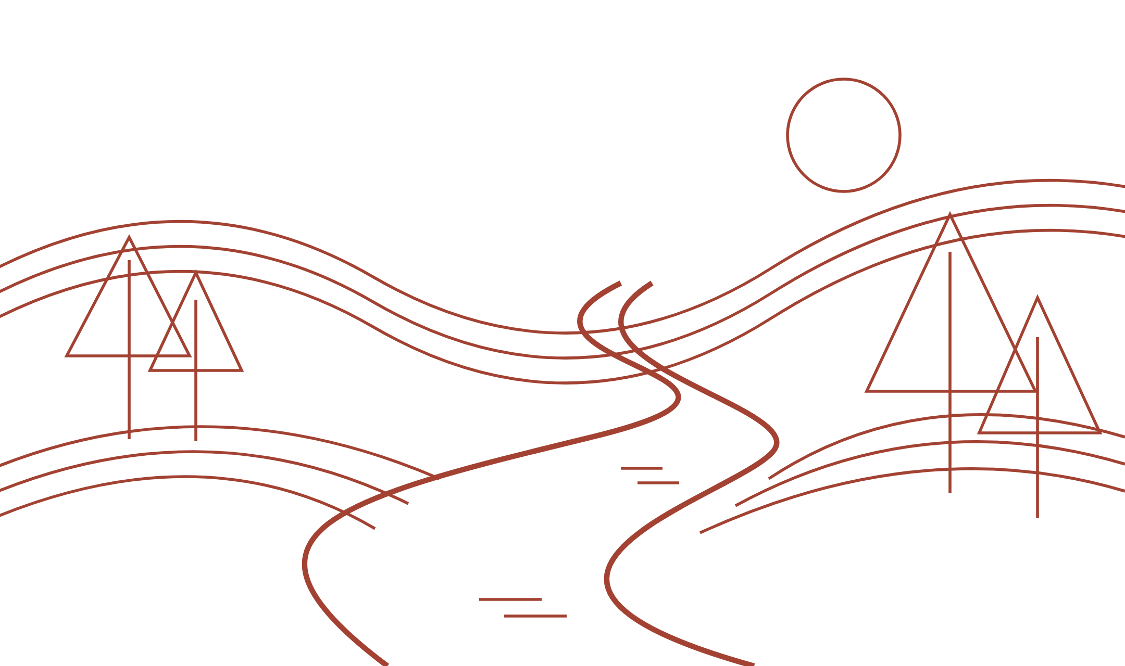
All locations are fictional examples.

THE LAY OF THE LAND · FICTIONAL EXAMPLES

Follow the gentle bend.
Set off at 16:00 and follow the Willow from your starting point to the old station, Willow Bridge, Riverside Books, and Sunset Pier.
2 km total walking distance · Suggested departure 16:00
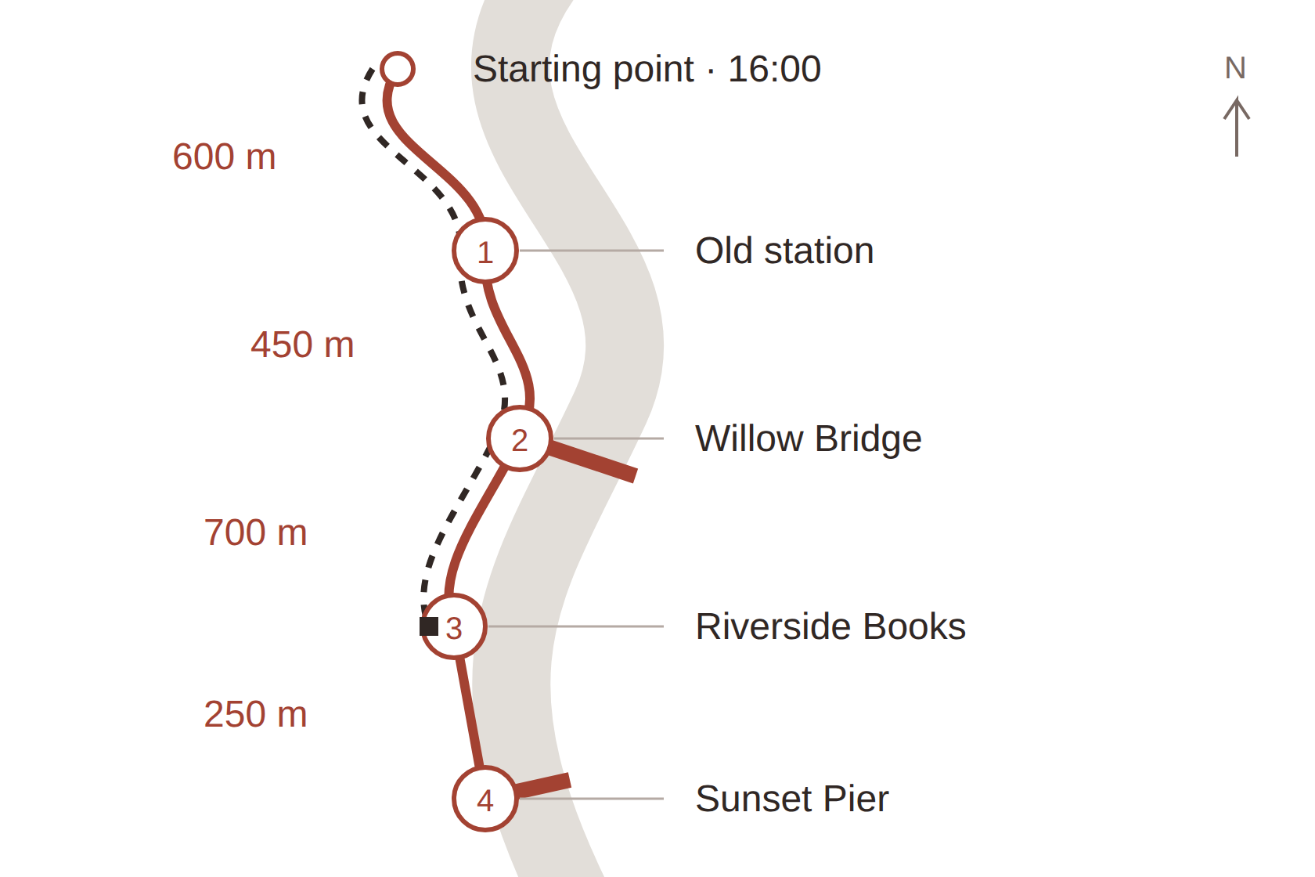
━━ Full route → Sunset Pier · 2 km
┄┄ Rainy day → Riverside Books · 1.75 km
Routes share the same path; lines offset for clarity.
Fictional examples · not to scale · pale band = river
Full: 600 + 450 + 700 + 250 = 2,000 meters.
Rainy day: 600 + 450 + 700 = 1,750 meters.

LITTLE PLACES TO PAUSE · FICTIONAL EXAMPLES

Let the walk unfold.
Set off at 16:00. Four stops, 2 km, and plenty of reasons to take your time.

01 Old station
Follow the river path to the quiet old station. Pause beneath its clock and imagine the weekend travelers who once passed through.
Starting point → station · 600 meters
Pause: 10 min · Sit: bench beneath the station canopy

02 Willow Bridge
Continue to the bridge framed by trailing willow branches. Stop at the railing to watch the river slip beneath you.
Station → bridge · 450 meters
Pause: 5 min · Sit: riverside bench beside the bridge

03 Riverside Books
The little bookshop overlooks the water. Browse a shelf, find a poem, or settle by the window for a few quiet minutes.
Bridge → bookshop · 700 meters
Pause: 20 min · Sit: reading chairs by the window

04 Sunset Pier
Finish at the wooden pier, where the view opens along the river. Sit awhile and watch the afternoon light soften on the water.
Bookshop → pier · 250 meters
Pause: 15 min · Sit: benches at the landward end

A LITTLE ROOM FOR NOTICING

Bring less. Notice more.
A comfortable pair of shoes, a little water, and something to sit on. Leave space for the unexpected.
☐ Water & a small snack
☐ A flask of something warm
☐ A light layer for the river breeze
IF THE RAIN COMES

A bookshop kind of afternoon.
Set off at 16:00: starting point → old station (600 m) → Willow Bridge (450 m) → Riverside Books (700 m). Finish indoors among the shelves.
1.75 km total walking distance · Skip the final 250 m to Sunset Pier. Take your station pause under the canopy; keep the bridge stop brief in rain.

What caught your eye?
A leaf, a sound, a moment…
________________________________________________________________
________________________________________________________________
All locations and seating are fictional examples,
created for this imagined weekend walk.

